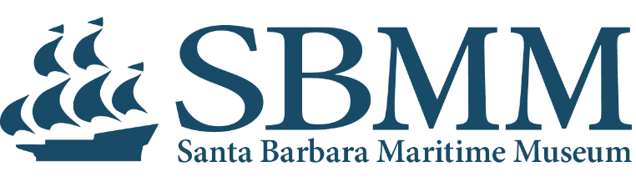

JOB DESCRIPTION

JOB TITLE: Collections and Curatorial Associate
Reports to: Curator/Director of Collections and Exhibits
Date: 10/01/2025

The collections and curatorial associate is responsible for managing and caring for SBMM’s collection in accordance with AAM best practices. This includes handling objects, maintaining databases, conducting research, and assisting with exhibitions and administrative tasks. Key responsibilities include documenting, tracking, and preserving artifacts, ensuring their safe storage and proper display. Additionally, this position provides support for collection-focused projects, exhibitions, and community outreach.

RESPONSIBILITIES

Collections

- Physically handle objects, prepare housing, and provide ongoing care and preservation.
- Enter, update, and manage collection data in a collections database, ensuring accuracy and integrity.
- Conduct historical research and respond to inquiries about the collection.
- Oversee management care and preservation of museum collections including cataloging, research, inventory, packaging, condition reports, and photographing of art objects/collection items.
- Evaluate works in need of conservation; make recommendations for remediation.
- Work with development team to research and apply for collections related grants.
- Supervise collections interns and volunteers when needed.

Registration

- Maintain artifact records including provenance, related materials, and movement within the museum/loans to other institutions.
- Prepare and maintain long-term loan partnerships for incoming and outgoing loans.
- Prepare and record accession and deaccession documents.
- Prepare list of acquisitions for regular reports.
- Oversee rights and reproduction requests to ensure proper licensing.

Curatorial

- Research artifacts to create new or updated text for permanent exhibits.
- Work with Education Department to provide educational content for exhibits.
- Pack and store traveling exhibits; work with Communications Department to advertise traveling exhibits.
- Assist with installation, display, packing, and unpacking of objects for exhibitions.
- Work on other curatorial exhibits and projects as needed.

Essential Skills and Qualifications

- Minimum three years’ experience in collections management with knowledge of museum collections care, object handling, and preventive conservation principles.
- Proficiency with collections management databases and proficiency in artifact condition assessments.
- Strong ability to conduct research, analyze information, and draft reports and correspondence.
- Excellent organizational, communication, and record-keeping skills, with accuracy and attention to detail.
- Ability to work independently and collaboratively.
- Ability to perform physical tasks, lifting, working on ladders to access and move objects.
- Knowledge of AAM’s Code of Ethics and Collecting Guidelines for Museums preferred.
- Bachelor’s degree (art history, fine arts, museum studies, or related field preferred).

This role is a 40 hour per week exempt position with a salary range of $67,000 to $75,000. Health benefits are provided including dental and vision, with opportunities for dependent coverage. SBMM also provides holiday, vacation, and sick pay, and a non-match 403 (b) and a SEP IRA.
Cover letter, resume, and three references can be submitted to Curator/Director of Collections Emily Falke at efalke@sbmm.org.

